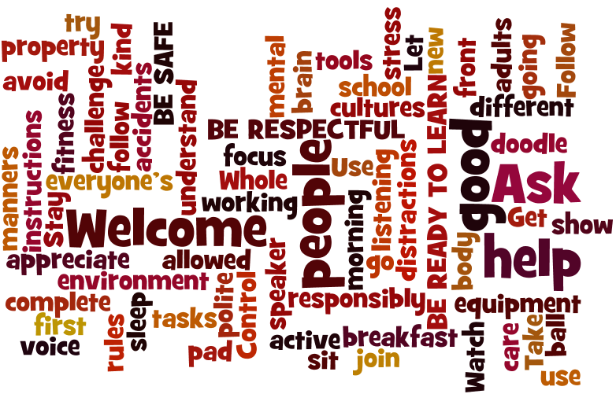 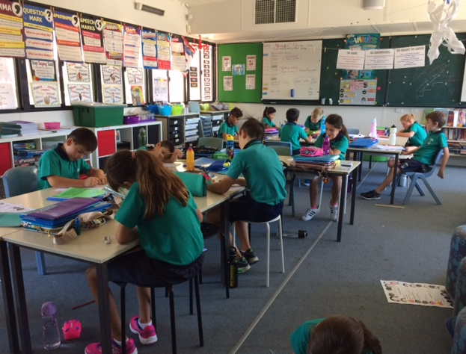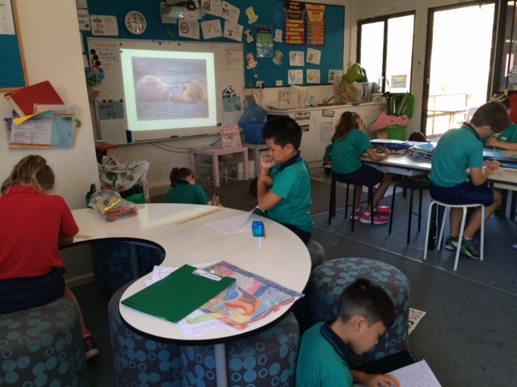

**LA 27 TEACHER CONTACT DETAILS**

Mrs Ella Marrion

[**Ella.Marrion@education.wa.edu.au**](mailto:Ella.Marrion@education.wa.edu.au)

Mrs Clodagh Murphy

In class (Fridays)

**HOMEWORK POLICY**

Students are expected to complete daily homework of **Reading** (a range of texts **to an adult**), **Spelling** and **Mental Maths** (tables and fast recall of basic facts). Work will also be set in **Mathletics** and **RAZ kids** at various times. Students are being issued with logins for online programs and these will be glued into their Homework and Communication books. Home Reading is recorded in a Reading Diary or sheet. **Students should have a regular homework time of 30 minutes daily.** Homework such as writing out tables, fast add and subtract facts or spelling should be completed in the Homework and Communication Book. **Reading Diaries and Homework Books are reviewed every Wednesday. Parents please sign the Reading Diary weekly.**

**HOME/SCHOOL COMMUNICATION**

All students have received a Homework and Communication Book. Please use this to keep us informed of any circumstances that may affect your child’s learning or to ask any questions if you are unable to catch up in person. You can also provide us with your email contact details if you prefer this. ***Your contact details and your child’s medical information should always be up to date.***

***Each week,***

**OTHER TEACHING STAFF**

**Mrs Della Gatta ESL Literacy**

**Ms Leanne Woods Literacy Support**

**Ms Clodagh Murphy Science/Fridays**

**Ms Abi Callow Art (tba)**

**Mr Victor Spano Art (tba)**

**Miss Emma Rogerson Music**

**Mrs Belinda Scott Italian**

**Mr Joshua Brown Physical Education**

Parenting Resources are also available in the Information Resource Centre under the banner of LEAP – Linking Education and Parents and on the ECE (Early Childhood Education) link on the school website**.**

**Parent Link is a new program to encourage parent-school collaboration. Please complete the sheet in the class if you wish to join.**

LIBRARY: Friday

MIDDLE SPORT: Thursday

**Preventative: creation of positive learning environment, incentives and support.**

**STEP 1:** Low level intervention – eye contact or, walk over to student’s desk.

**STEP 2:** Verbal warning or quiet reminder card on desk.

**STEP 3:** Remove or isolate the student or the problem in class - sit at desk in front of teacher or on mat.

**STEP 4:** Time out in class or in buddy room to fill out reflection sheet - sent home for parent signature.

**STEP 5:** Orange (repeated occasions reaching Step 4). Referred to Office.

**STEP 6:**Red (very serious). Referred directly to office. Maybypass the stepsabove (dependingon seriousness).

**THE BUMP CHART:**

**BEHAVIOUR CONSEQUENCES**

YEAR 3 / 4

LA 27

Parent Information Evening

13 February 2018

**LANDSDALE PRIMARY SCHOOL**

The Broadview

Landsdale, WA. 6065

Phone: 9302 4100

<https://www.landsdaleps.wa.edu.au/>

***Don’t forget to ‘Like’ us on Facebook!***

Ashdale Cluster of Independent Public Schools

**LA 27 SUPPORT ACTIVITIES**

Students are being assessed in mathematics, grammar, spelling, writing and reading to determine their current learning needs. Some students will attend the Huff & Puff sessions. Support programs will be offered including those available within the school such as the extremely successful Letters and Sounds program. **I will be contacting some parents to offer appointments to discuss individual student needs – especially where your child needs additional support to work towards their potential, or requires extension.**  Provision for extension is made in all lessons. ***From Week 4, I will offer some students additional after-school tutoring for 1 hour at no cost to parents.***

**BEHAVIOUR MANAGEMENT**

Our school’s **Positive Education Policy** aims to establish and maintain high quality, positive relationships between staff, students, parents and the wider school community. We have a whole-school approach to Values – our IValues. LA 27 have developed **our own Behaviour Expectations to show how we will *Be Safe*, *Be Respectful* and *Be Ready to Learn*.** This is displayed in class, along with our **Bump Chart for consequences**. More details are on the back of this brochure. The consequences follow a ‘least to most intrusive’ approach to behaviour management and are supported by our **IValues program**. ***IValues include: I Think Clearly; I am Responsible; I am a Global Citizen; I Think Creatively; I Work Well With Others and I Make Good Choices.***

**STUDENT WELLBEING**

Bullying is not acceptable in any school or workplace. Our Health program will address this area as well as Digital Citizenship, Healthy Eating, Meditation and Relaxation Strategies, and how to build and maintain a positive self-image, resilience, self-care & friendships.

**DIGITAL TECHNOLOGIES**

Year 4s will have the 1:1 Apple program. We have 6 iPad Airs to share between Year 3s. Students will be taught Digital Citizenship skills *(IPromise)* [**https://www.esafety.gov.au/**](https://www.esafety.gov.au/)

Students will also learn to use Cloud technology (Google Drive & Classroom). Science, Technology, Engineering and Mathematics (STEM) will form part of our program.

**GLOBAL EDUCATION**

Aims to develop young people who are engaged and informed about their world and who have a sense of empowerment in shaping a positive future – being active citizens of their community and the world. Students work on real world, authentic projects in teams. Skills developed include: teamwork, self-organisation, leadership, project planning, problem solving and digital skills. Other learning areas are integrated, as well as our IValues and the Australian Curriculum General Capabilities and Cross Curriculum Priorities: Sustainability; Aboriginal and Torres Strait Islander histories and cultures, and Australia’s engagement with Asia. Our three projects for this year are:

* Expand Vegetables /orchard area;
* Reduce single-use plastic bag use;
* Investigate the status of the black cockatoo in the local area and make recommendations to the local council and community.

**SCHOOL PRIORITIES**

Our school priorities are: **English – especially developing oral reading fluency** (rate, accuracy, punctuation, expression) **and reading comprehension** – especially where higher-order thinking is required. **Year 3 students need to read age-appropriate texts at around 107 words correct per minute to develop comprehension skills. Year 4 students need to read around 123 words correct per minute (wcpm).**

Other **priorities** are **Numeracy – especially fluency or rapid recall of number facts** (addition and subtraction facts; 2, 5, 10, 11, 12, 3 and 4x tables by the end of Semester 1). **Mathematical problem-solving** and **Writing** are also key priorities. In Spelling, we implement the **Diana Rigg phonics program** with a new focus sound every 7-8 days. New Spelling lists will be written into Homework books. ***In Term 1, we focus on Naplan preparation. Year 4s will be offered Year 5 extension where appropriate and can do a practice Year 5 Naplan.***

There are a number of **online resources and websites** to support your child that the school or individual teacher subscribes to. Please use these to provide an alternative, engaging method to traditional pen/paper homework. **Logons are gradually being glued into Homework and Communication books.**

* Studyladder – [www.studyladder.com](http://www.studyladder.com)
* Ziptales (school subscription) <https://www.ziptales.com/student/index.php>
* Mathletics <http://www.mathletics.com.au/>
* RAZ Kids (teacher subscription) <https://www.kidsa-z.com/main/Login>

**Welcome to a new year of learning, friendship and fun at Landsdale Primary School in 2018.** Your child is now in middle school; an important milestone that entails new challenges and the chance to work more collaboratively and independently as well as develop lifelong strategies to support personal responsibility, social integration and emotional resilience.

Your child’s teachers are: Mrs Marrion (Monday to Thursday) and Mrs Murphy (Friday). LA 27 is part of the Year 3 and Year 4 teams. Teachers plan, and will be moderating, key pieces of student assessments collaboratively. Mrs Murphy also teaches Science and will use both our classroom and the Science room. ***Please check the class website for resources and weekly news.*** Class website <http://mrsmarrion.weebly.com/>

**WEST AUSTRALIAN CURRICLUM**

In 2018, we will teach English, Mathematics, HASS (Humanity & Social Science – History, Geography, Civics and Citizenship), Science and Technology – including Digital Technology using the WA curriculum. Both Year 3 and Year 4 curricular are covered. Our topic in Term 1 History is Community and Celebration for Year 3; however, I will teach the Enquiry Process for research to both year levels. In Geography, for Year 3, we cover Australia’s states, territories and natural features. For Year 4, we revise these and also study climate, vegetation, natural features and animals for the continents Africa & Europe.

More detail is available at:

<https://k10outline.scsa.wa.edu.au/home/teaching/curriculum-browser>

[**https://www.australiancurriculum.edu.au/parent-information/**](https://www.australiancurriculum.edu.au/parent-information/)