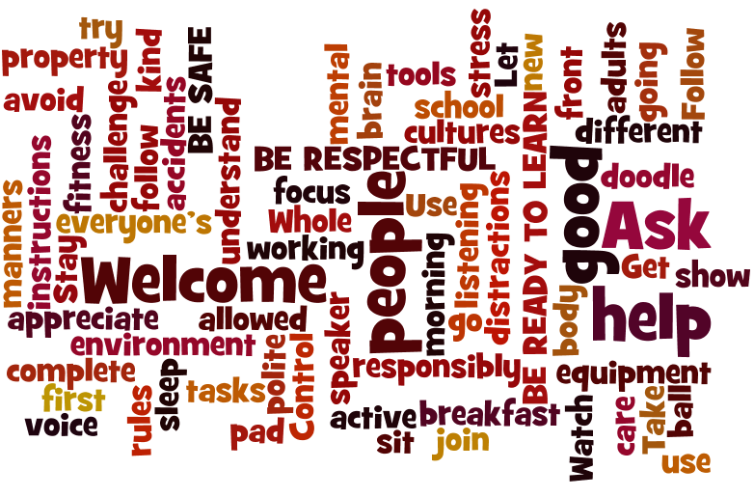

**Preventative: creation of positive learning differentiated environment, incentives & support.**

**STEP 1:** Low level intervention – eye contact or, walk over to student’s desk.

**STEP 2:** Verbal warning.

**STEP 3:** Remove or isolate the student or the problem in class - sit at desk in front of teacher or on mat.

**STEP 4:** Time out in class or in buddy room to fill out reflection sheet - sent home for parent signature.

**STEP 5:** Orange (repeated occasions reaching Step 4). Referred to Office.

**STEP 6:**Red (very serious). Referred directly to office. Maybypass the stepsabove (dependingon seriousness).

**BEHAVIOUR RESPONSE STEPS**

**HOMEWORK POLICY**

Students are expected to complete daily homework of **Reading** (a range of texts **to an adult at least 3-4 times a week**), **Spelling** and **Mental Maths** (tables and fast recall of basic facts). Spelling includes revision of D. Rigg Year 1 – 3 sight words. Work will also be set in **Mathletics**. Students are being issued with logins for online programs and these will be glued into their Homework and Communication book. Home Reading is recorded in a Reading Diary. **Students should have a regular homework time of 30 minutes daily.** Homework such as writing out tables, fast mental maths facts or spelling can be completed in the Homework and Communication Book. **Reading Diaries and Homework Books are reviewed every Friday. Parents please sign the Reading Diary weekly.**

**HOME/SCHOOL COMMUNICATION**

We use Class Dojo to communicate with parents/caregivers, along with the Parent Link program. Students received a Homework and Communication Book. Please use Class Dojo, the Communication book, or you can also use email to keep us up to date with information about your child. ***Your contact details and your child’s medical information should always be up to date.***

Science/Music (odd weeks) Monday

Italian Tuesday

Early Close: Wednesday

Art/Middle Sport: Thursday

Phys. Ed./Library Friday

**LA 27 TEACHER CONTACT DETAILS**

Mrs Ella Marrion

[**Ella.Marrion@education.wa.edu.au**](mailto:Ella.Marrion@education.wa.edu.au)

**OTHER TEACHING STAFF**

**Mr Joseph Smart Science**

**Zara Wrubel/Tegan Zammit Mini Lit support**

**Ms Liza Gandy Art**

**Ms Keller Music**

**Miss Gouldstone Italian**

**Mr Joshua Brown Physical Ed.**

Parenting Resources are also available in the Information Resource Centre under the banner of LEAP – Linking Education and Parents and on the ECE (Early Childhood Education) link on the school website**.**

**Parent Link is a program to encourage parent-school collaboration and information. Please complete the sheet in the class if you wish to join.**

YEAR 3

LA 27

Parent Information Evening

22 February 2023

**LANDSDALE PRIMARY SCHOOL**

The Broadview

Landsdale, WA. 6065

Phone: 08 9408 3850

<https://www.landsdaleps.wa.edu.au/>

Ashdale Cluster of Independent Public Schools

**BEHAVIOUR MANAGEMENT**

Our school’s **Positive Education Policy** aims to establish and maintain high quality, positive relationships between staff, students, parents and the wider school community. We have a whole-school approach to Values – our IValues. LA 27 have developed **our own Student Expectations and Responsibilities to show how we will *Be Safe*, *Be Respectful* and *Be Ready to Learn*.** This is displayed in class, along with the School-wide **consequence/response steps.** More details are on the back of this brochure. The consequences follow a ‘least to most intrusive’ approach to behaviour management and are supported by our **IValues program**. ***IValues include: I Think Clearly; I am Responsible; I am a Global Citizen; I Think Creatively; I Work Well With Others and I Make Good Choices.***

**STUDENT WELLBEING**

Students will participate in a school-wide online survey about Wellness using the Rumble’s Quest program. Aspects of our Health program will be based on issues identified in this survey. ***Bullying is not acceptable in any school or workplace.*** Our Health program will address this area as well as Digital Citizenship; Healthy Eating; Meditation and Relaxation Strategies; how to build and maintain positive self-images, resilience; self-care & friendships using ‘**Zones of Regulation’ and ‘UR Strong’**. We ‘Just Breathe’ daily 1.50pm 3 days a week.

Welcome to a new year of learning, friendship and fun @ Landsdale Primary School in 2023. Year 3 is an important year for catching up and building on academic and social/emotional development. It entails new challenges and the chance to work more collaboratively and independently, as well as develop lifelong strategies to support personal responsibility, self-organisation and regulation. Social integration and emotional resilience development are also supported.

Your child’s teacher is Mrs Ella Marrion. LA 27 is part of the Year 3 teaching team. Teachers plan and moderate key pieces of student assessments collaboratively. Please check the class website for resources and weekly events. Class website: <http://mrsmarrion.weebly.com/>

**WEST AUSTRALIAN CURRICULUM**

We teach English, Mathematics, HASS (Humanity & Social Science – History, Geography, Civics & Citizenship), Science and Technology – including Digital Technology using the WA curriculum. Our term 1 History topic is Celebration and Commemoration. In Geography we will study Australia states, territories, cities, oceans seas, flags symbols and natural features. I will teach the Inquiry Process for research, including note-taking skills**. *Our overarching goal will be to ‘Make a Difference – Change our World to live more sustainably’. We will do this by integrating curriculum and working together to apply skills in ‘real world contexts’.***

**More detail is available at:**

[**https://www.australiancurriculum.edu.au/parent-information/**](https://www.australiancurriculum.edu.au/parent-information/)

[**https://parent.scsa.wa.edu.au/what-will-my-child-learn**](https://parent.scsa.wa.edu.au/what-will-my-child-learn)



**DIGITAL TECHNOLOGIES**

Year 3’s participate in the 1:1 device program with a school-allocated iPad each. Students will be taught Digital Citizenship skills *(IPromise, Acceptable User Agreement)* [**https://www.esafety.gov.au/**](https://www.esafety.gov.au/)

Students also learn to use Cloud technology (Google Drive & Classroom). Science, Technology, Engineering and Mathematics (STEM) will form part of our program.

**GLOBAL EDUCATION**

Aims to develop young people who are engaged and informed about their world and who have a sense of empowerment (voice and agency) in shaping a positive future – being active citizens of their community and the world. Students work on real world projects in teams. Skills developed include teamwork, self-organisation, leadership, planning, working to deadlines, problem solving and digital technology skills. Other learning areas are integrated, as well as our IValues and the Australian Curriculum General Capabilities and Cross Curriculum Priorities: Sustainability; Aboriginal & Torres Strait Islander histories & cultures, and Australia’s engagement with Asia. Projects selected relate to living sustainably and making a difference to our future.

**SCHOOL PRIORITIES**

Our school priorities are: **Student Wellness** (connection, friendship, differentiation); **English – especially developing oral reading fluency** (rate, accuracy, punctuation, expression); **reading comprehension** – especially with interpreting explicit information; making connections; inferring, and **vocabulary**. **Year 3 students need to read age-appropriate texts at around 92 words correct per minute (wcpm) in Semester 1 and 107 wcpm in Semester 2 to develop comprehension skills.**

Other **priorities** are **Numeracy – especially fluency or rapid recall of number facts** (addition and subtraction facts; 2, 5, 10, 3 and 4x tables by the end of Semester 1). Learning **Mathematical problem-solving** **strategies and terminology** are also key areas. We teach **Writing using both the ‘Talk for Writing’ & ‘7Steps to Writing Success’ programs**. In Spelling, we implement the **Diana Rigg phonics program** with a new focus sound every 7-8 days. Each new spelling list will be written into Homework books. ***This program is individualized for each student, rather than group-based.***

There are a number of **online resources and websites** to support your child that the school or individual teacher subscribe to. Please use these to provide an alternative, engaging method to traditional pen/paper homework. **Logons are gradually being glued into Homework and Communication books.**

* Studyladder – [www.studyladder.com](http://www.studyladder.com)
* Ziptales (school subscription) <https://www.ziptales.com/student/index.php>
* Mathletics <http://www.mathletics.com.au/>
* RAZ Kids (teacher subscription) <https://www.kidsa-z.com/main/Login>
* Readiwriter <http://www.3plearning.com/software/readiwriter/> (teacher subscription)

**LA 27 SUPPORT ACTIVITIES**

Students have been assessed in mathematics, spelling, writing and reading to determine their current learning needs. Some students will access the MiniLit literacy support and/or the Bond Blocks mental maths support program. **I will continue to contact some parents to offer appointments to discuss individual student needs – especially where your child needs additional support to work towards their potential or requires extension.**  In class curriculum adjustments are made for students who may require differentiation.

***Provision for extension and support occurs in most lessons.***